2016 NMDA YTD Financial Report (through 5/31/16)
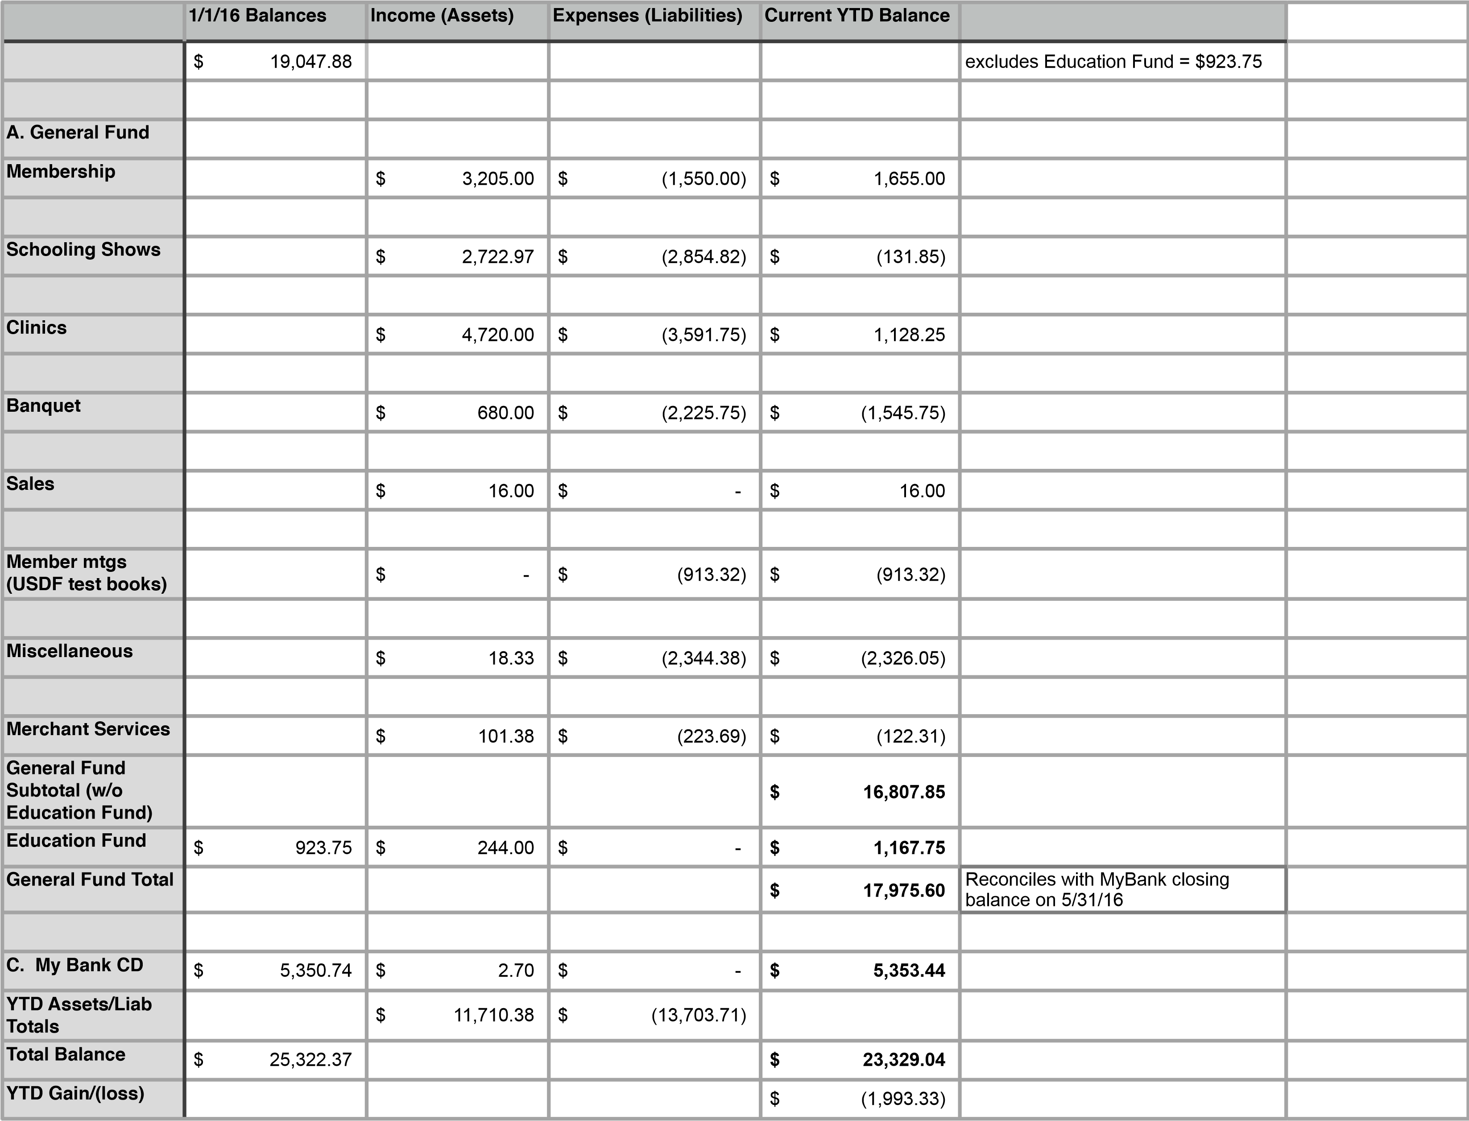
1

